**FORM 4: RESULTS AND CONCLUSION**

**TEAM NO:** 12

**PROJECT TITLE:** IOT BASED SOLAR POWER MONITORING SYSTEM

**EXPERIMENT ENVIRONMENT:**

* **Arduino IDE:**

The Arduino IDE is an open-source software, which is used to write and upload code to the Arduino boards. The IDE application is suitable for different operating systems such as **Windows, Mac OS X, and Linux**. It supports the programming languages C and C++.

* **IOT Platform:**

ThingSpeak is an IoT analytics platform service that allows you to aggregate, visualize, and analyze live data streams in the cloud. You can send data to ThingSpeak from your devices, create instant visualization of live data, and send alerts

* **Programming Language:**

The IoT monitoring application was developed using the C programming language for its efficiency, low-level control capabilities, and suitability for embedded systems programming, making it an ideal choice for interfacing with hardware components and implementing real-time data processing algorithms.

* **Hardware Components:**

Arduino microcontrollers and sensors were utilized in the experiment for capturing solar power generation parameters such as sunlight intensity, voltage, and current. These components were seamlessly integrated with the ThingSpeak platform for transmitting data in real-time and facilitating comprehensive analysis.

**EXPERIMENT:**

We have created an IOT based project, where we use the C programming language to control different IoT components, helping us collect and analyze solar energy data efficiently.

**FINDINGS 1: Performance Analysis of Solar Panels**

In our experiment with the IoT-based solar power monitoring system, we observed compelling findings across multiple parameters. Firstly, examining the voltage over time revealed fluctuations correlating with solar exposure. During peak sunlight hours, voltage levels surged, indicating heightened energy generation, while they dipped during periods of reduced sunlight or cloud cover.

Simultaneously, monitoring current over time provided insights into energy consumption patterns. The current exhibited peaks during daylight hours, aligning with increased energy generation, and decreased during nighttime or cloudy conditions when solar panel output diminished.

Temperature fluctuations also played a significant role in system performance. As expected, solar panels exhibited higher temperatures during peak sunlight hours, influencing energy generation. We noted a direct correlation between temperature and energy output, with higher temperatures typically resulting in increased energy generation due to enhanced efficiency.

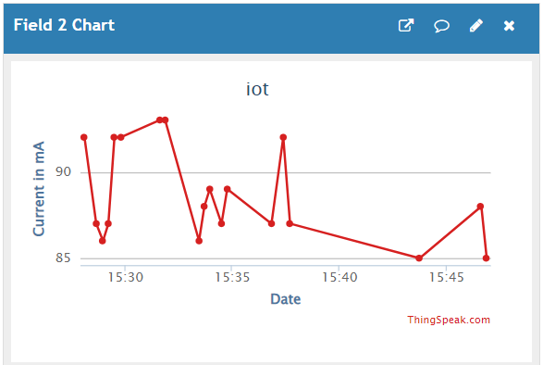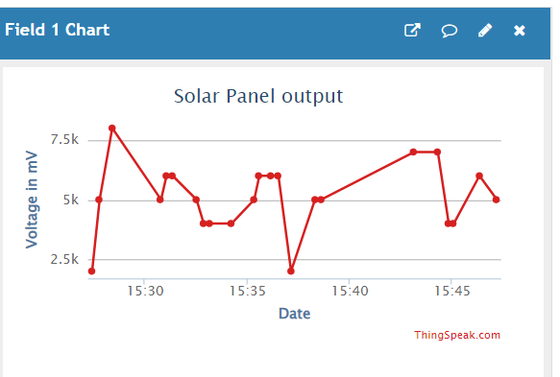

Voltage vs Time Graph Current vs Time Graph

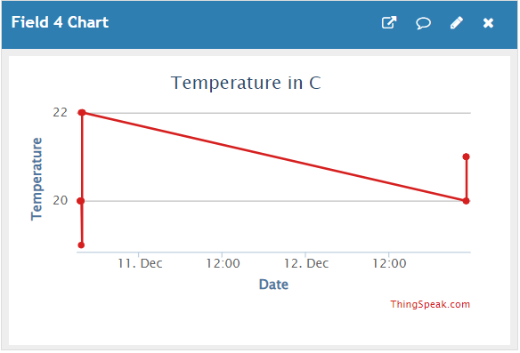

Temperature vs Time Graph

**FINDINGS 2: Environmental Impact on System Operation**

Humidity vs. time data provides insights into the environmental conditions affecting the solar power monitoring system. Generally, humidity levels exhibit gradual changes over time, influenced by factors such as weather patterns and time of day. However, sudden increases in humidity are observed during periods of rapid temperature drop, typically occurring in the late afternoon or evening.

These sudden increases in humidity coincide with a decrease in temperature, indicating a potential correlation between temperature changes and humidity levels. It's hypothesized that as temperatures drop rapidly, moisture in the air condenses, leading to a sudden spike in humidity levels. This phenomenon may have implications for system operation, particularly in terms of moisture ingress and its impact on system components.

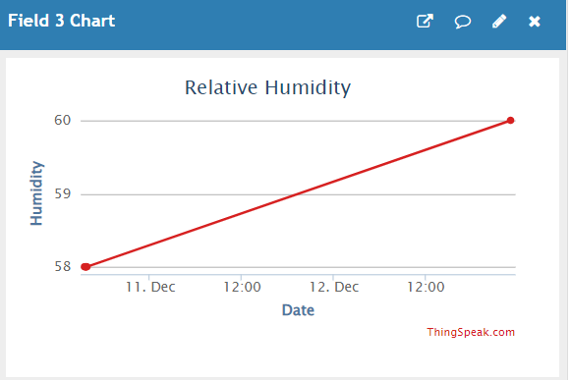

Humidity vs Time Graph

**FINDINGS 3: System Resilience and Adaptability**

When sudden changes in humidity occur due to temperature drops, our solar power monitoring system responds swiftly and accurately. It captures these fluctuations in humidity in real-time, showing how well it can adapt to unexpected environmental shifts. This quick response highlights the system's ability to handle changing conditions effectively, ensuring that it can keep performing well even when faced with sudden changes in weather.

Moreover, our system's capability to adjust to these environmental variations demonstrates its reliability and durability in different situations. By being proactive and responsive to sudden spikes in humidity caused by temperature changes, the system can anticipate potential issues and address them before they become problems. This adaptability ensures that our solar power generation setup remains dependable and continues to operate efficiently, regardless of the environmental challenges it may encounter.

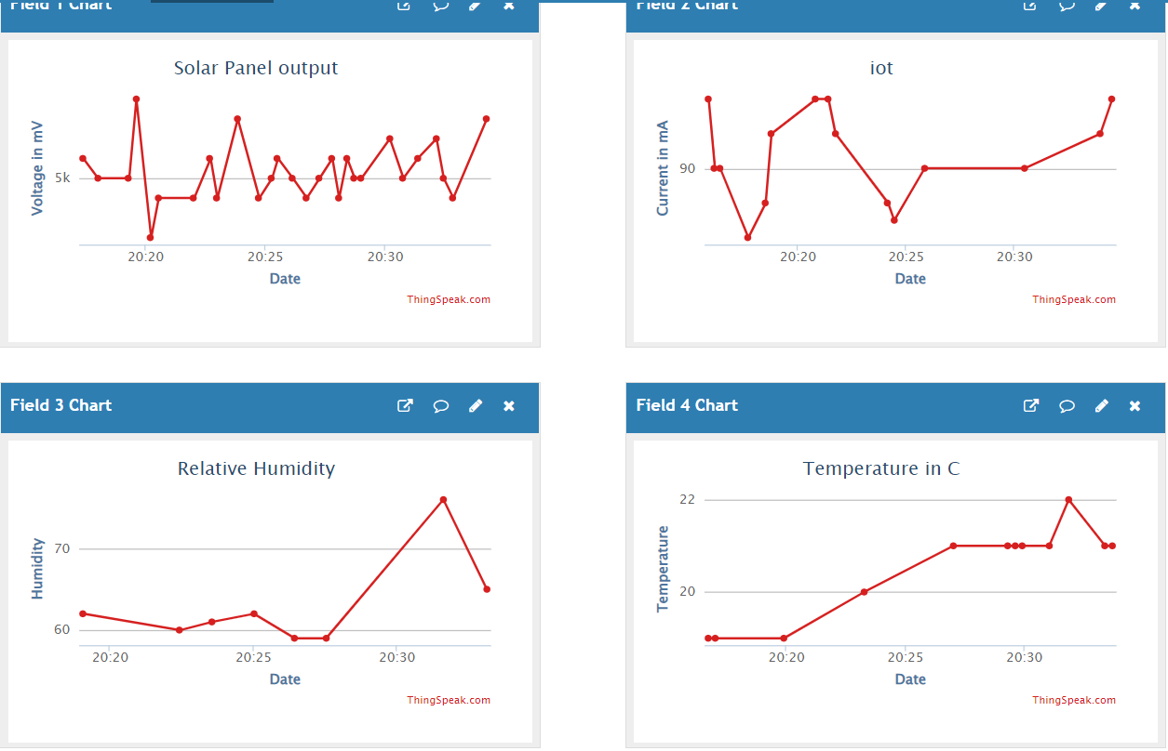

Sudden increase in humidity due to cold weather

**PARAMETER COMPARISION TABLE:**

|  |  |  |
| --- | --- | --- |
| **PARAMETER** | **PREVIOUS METHODS** | **PROPOSED METHOD** |
| Solar Power Output | Manual Reading | The previous method relied on manual readings of solar power output, which were prone to human error and limited in frequency. The proposed method utilizes IoT-based monitoring, enabling continuous and automated measurement of solar power output in real-time. This approach provides more accurate and frequent data, allowing for better optimization of energy production. |
| Data Accuracy | Moderate | The previous method resulted in moderate data accuracy due to the reliance on manual readings and infrequent data collection. The proposed method significantly improves data accuracy by leveraging IoT technology, which enables precise measurement and continuous monitoring of solar power generation parameters. This ensures that the data obtained is reliable and reflects the actual performance of the solar energy system. |
| Accessibility | Local Access | With the previous method, access to monitoring data was limited to local access points, requiring physical presence for data retrieval and analysis. In contrast, the proposed method offers remote accessibility through IoT connectivity. Users can access monitoring data from anywhere via a web interface or mobile application, enhancing convenience and enabling timely decision-making regardless of location |
| Real-time Monitoring | No | The previous method lacked real-time monitoring capabilities, as data collection was manual and infrequent. In contrast, the proposed method provides real-time monitoring of solar power generation parameters. By continuously collecting and analyzing data in real-time, users can promptly identify performance issues or anomalies and take immediate corrective actions to optimize energy production and system efficiency |

**FINAL CONCLUSION STATEMENTS:**

The implementation of an IoT-based solar power monitoring system signifies a significant leap forward in renewable energy management, offering real-time monitoring, remote accessibility, and heightened data accuracy compared to manual methods. Through continuous tracking of solar power generation parameters like sunlight intensity and voltage, this system enables proactive decision-making to optimize energy production and system efficiency. Its remote accessibility empowers users to monitor and manage solar power systems from anywhere, enhancing convenience and facilitating efficient energy management. Overall, the adoption of IoT technology in solar power monitoring not only addresses the limitations of traditional methods but also underscores a commitment to innovation, sustainability, and the efficient utilization of renewable energy resources.

Signature of Project In-charge